Exercises grade 4
Unit 12 – lesson 2 and lesson 3
I. Circle the correct word.
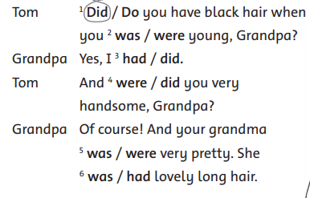


II. Choose the correct word.

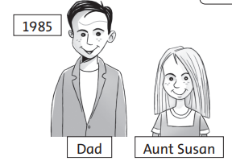
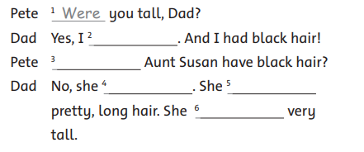

Answer key
I. Circle the correct word.
2) were 3) did 4) were 5) was 6) had
II. Choose the correct word.
2) was 3) Did 4) didn’t 5) had 6) wasn’t

